Name ____________________________ HOMEWORK Sept 27-Oct 1
Module 2 Week 2
Put your initials by each night that your child practiced the following:
____Monday ____Tuesday ____Thursday
*Nightly Homework*
1. Practice saying letter names and sounds.
2. Count numbers 1-25.
3. Practice assigned Sight Word list.

Say the following letter names and sounds.
Mm Ss Tt Bb Aa

Monday- Count and circle the number of syllables in each word.

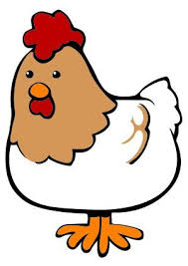

1 2 3 4 1 2 3 4 1 2 3 4 1 2 3 4

Read it. Trace it. Write it.
am am ______
at at ______
go go ______

Tuesday – Write the beginning sound for each word.

________ _________ __________ __________
Thursday- Draw pictures of things beginning with:
Short A Long A

Write a sentence about your favorite animal.

Star Right Reader
(Please let your child read this to you.)

Words to know
at go
At Bat
See Sam at bat.
Bam! Go, Sam!
See the ball go!
See the bird!
Bam!
See Tab catchthe ball!

